|  |  |
| --- | --- |
| **Logo_FPT_University_doc** | **MINISTRY OF EDUCATION AND TRAINING** |

|  |
| --- |
| **FPT UNIVERSITY** |
| Capstone Project Document |
| Drop It |
|  |
| |  |  | | --- | --- | | **Group 08** | | | **Group Members** | Lê Khôi Phong  Đào Như Tùng  Công Minh Hiếu  Nguyễn Thanh Tùng  Đặng Quốc Duy | | **Supervisor** | Lâm Hữu Khánh Phương | |
|  |

- Ho Chi Minh City, 08/2013 –

**Record of Changes**

|  |  |  |  |  |
| --- | --- | --- | --- | --- |
| **Date** | **Changed Item** | **Description** | **By** | **Version** |
| Aug-1-2013 | All | Create the document | TungNT | 0.1 |
|  |  |  |  |  |
|  |  |  |  |  |

Table of Contents

**No table of contents entries found.**

# Installation Guide

## **Setting up the environment at server side**

The following software must be installed into the server machine:

#### **Hardware requirements:**

* Personal computers for developing with the minimum configuration: CPU Core 2 Duo 2.0GHz, 4GB of RAM, 120GB of hard disk, and internet.

#### **Software requirements**:

* + Operating system: Windows 7, Windows Server 2008 R2 or higher
  + Web Server: IIS 7.5 or higher
  + Microsoft SQL Server 2012 or higher: used to create and manage the database for web application

## **Deployment at server side**

# User‘s Guide

## **Admin’s Guide**

### Active/Deactive User

* Click on “Người dùng” tab to enter Manage User page

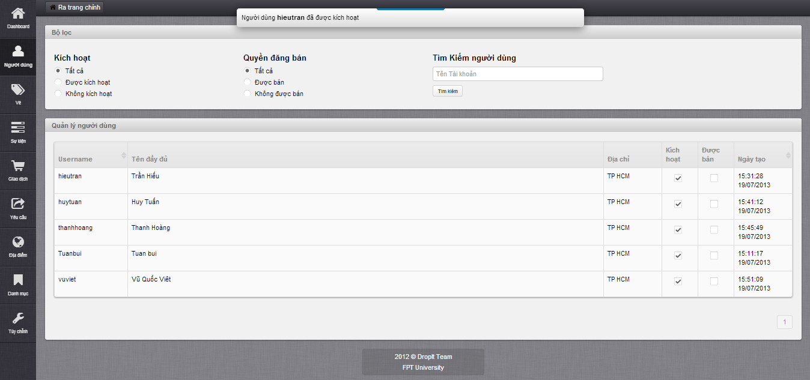

* Choose deactive user and check “Kích hoạt” box to active
* Choose active user and uncheck “Kích hoạt” box to deactive
* Message active/deactive successful displays on top

### Salable/Unsalable User

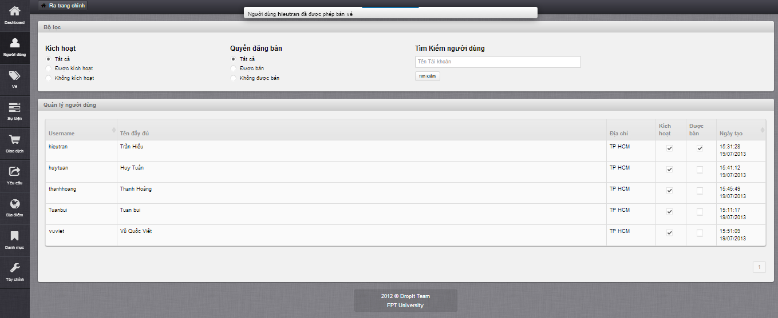

* Choose unsalable user and check “Được bán” box to allow selling
* Choose salable user and uncheck “Được bán” box to not allow selling
* Message salable/unsalable successful displays on top

### Update Ticket

* Click on “Vé” tab to enter Manage Ticket page

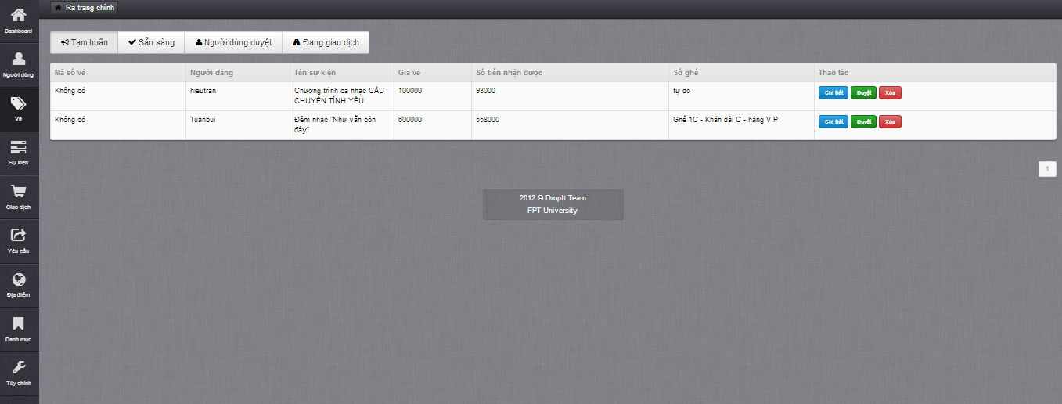

* Click on “Chi tiết” button to view ticket details and update ticket

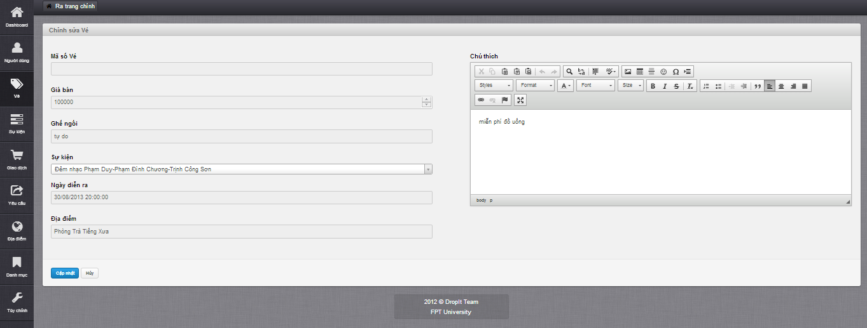

* In edit ticket page, only field “Sự kiện” can be edited
* After edited, click “Cập nhật” to save

### Delete Ticket



* Click on “Xóa” button to delete ticket

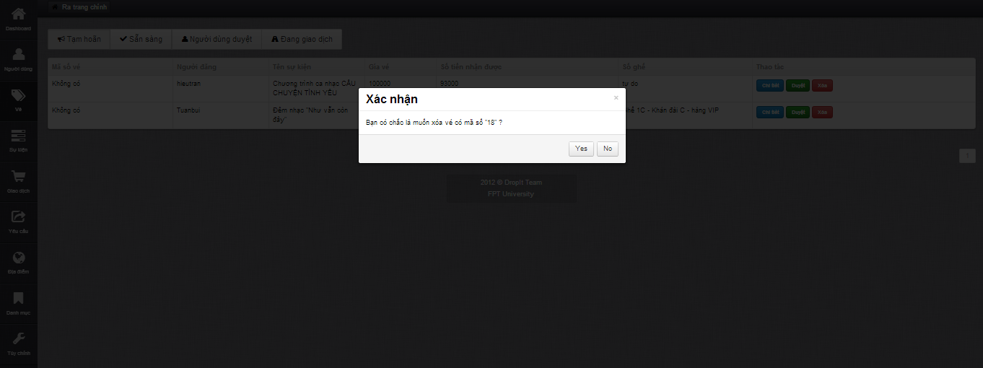

* Click “Yes” button to confirm delete ticket, finish delete

### Approve/Disapprove Ticket

* Click on “Duyệt” button to approve a ticket
* Click on “Bỏ duyệt” button to disapprove a ticket

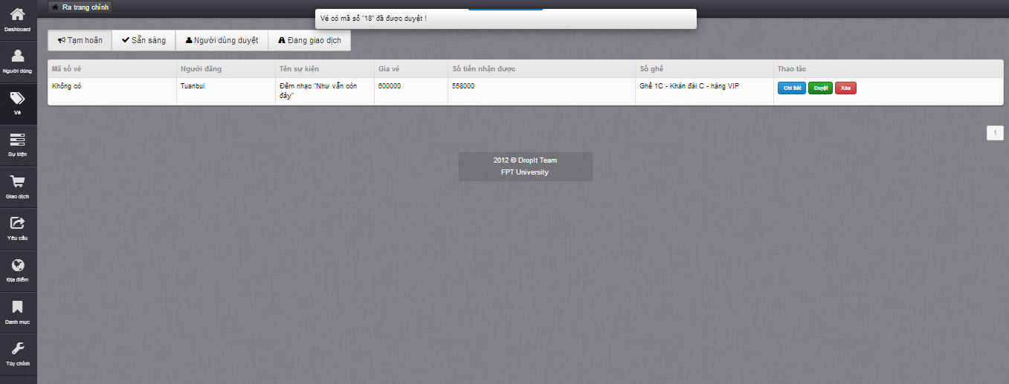

* Message approve/disapprove successful displays on top

### Create Event

* Click on “Sự kiện” tab to enter Manage Event page

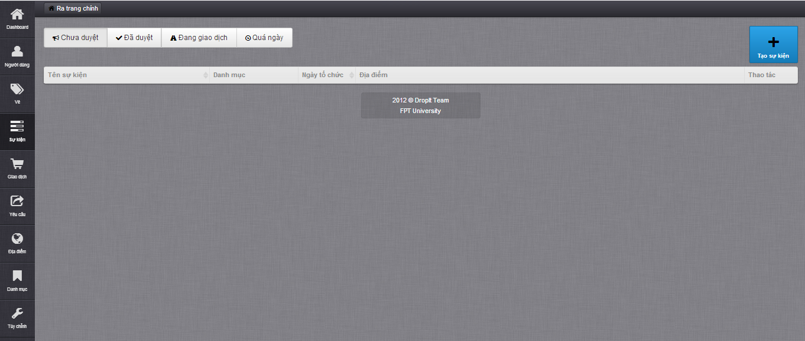

* Click on “Tạo sự kiện” button to display Create Event page

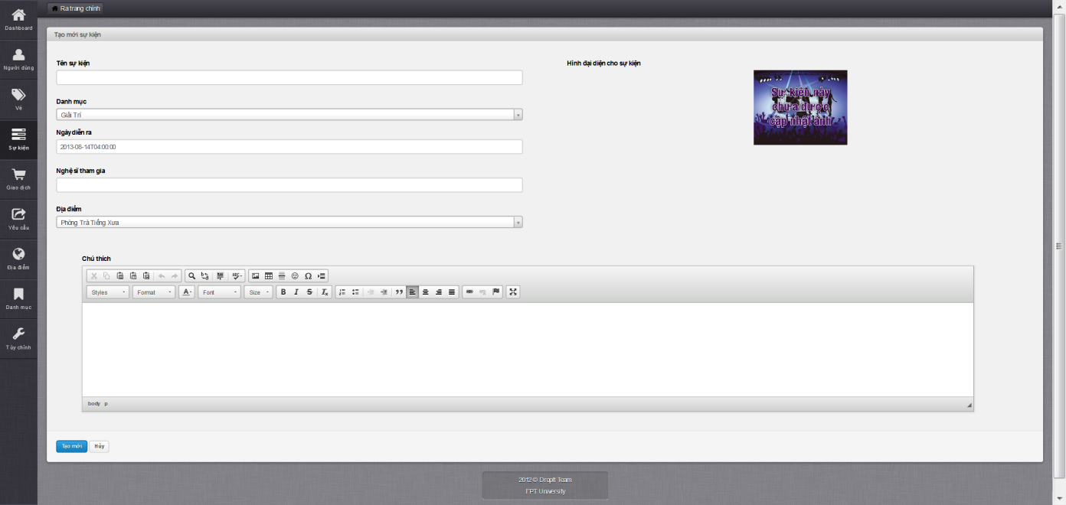

* Fill in all mandatory field
* Click on “Tạo mới” button
* After creating completed, navigate back to Manage Event page

### Update Event

* Click on an event to display Update Event page

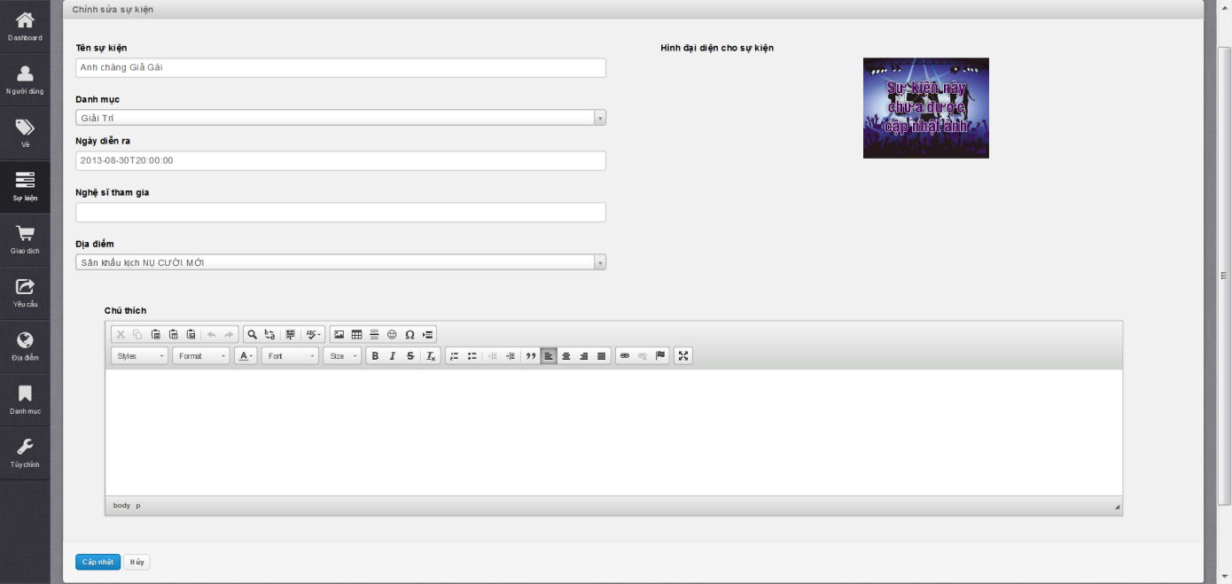

* Fill in need to update field
* Click on “Cập nhật” button
* After updating complete, navigate back to Manage Event page

### Delete Event

* Choose an event in Disapprove tab and click “Xóa” button

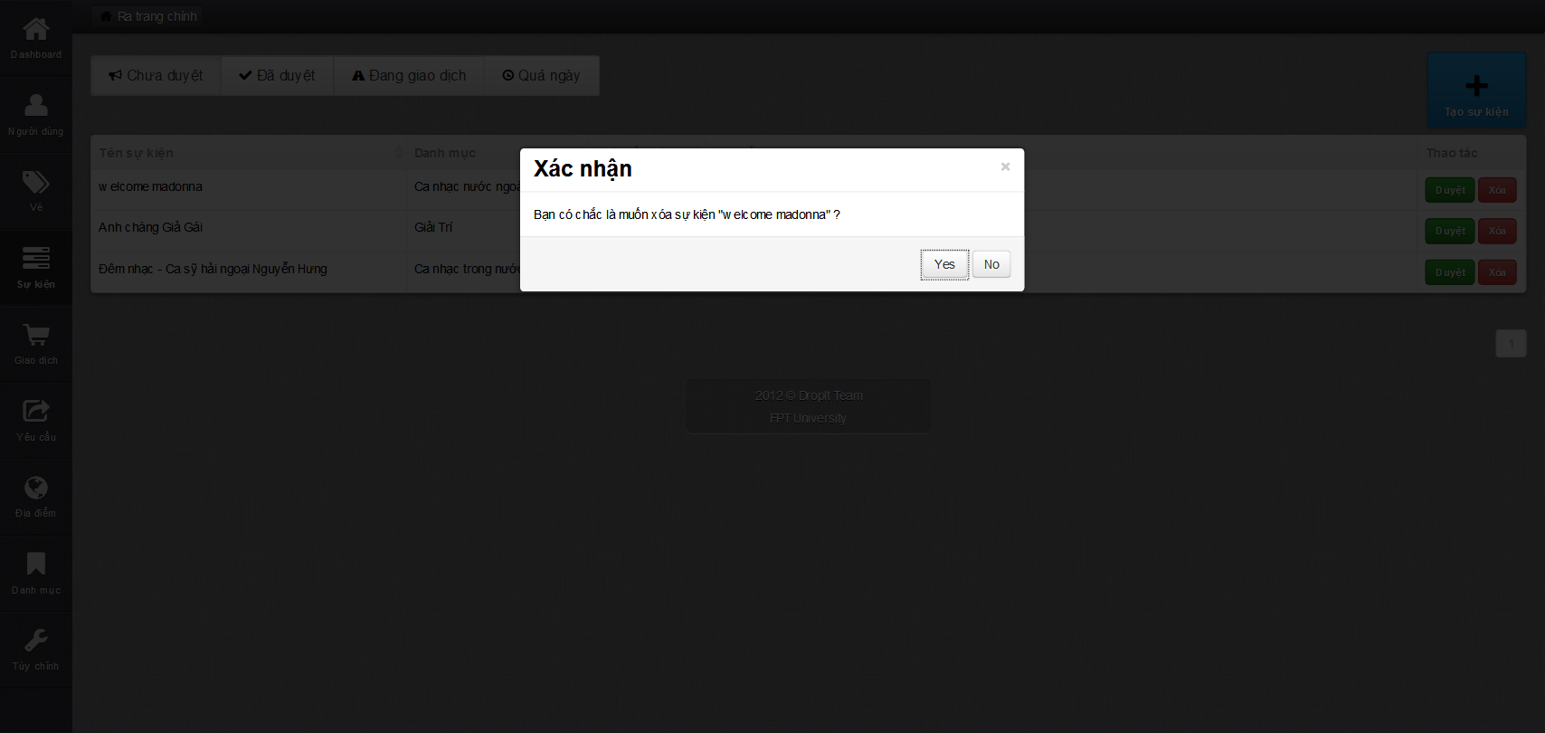

* Click on “Yes” button to confirm delete event, finish delete event

### Approve/Disapprove Event

* Choose a disapprove event in “Chưa duyêt” tab and click “Duyệt” button to approve event
* Choose a disapprove event in “Đã duyêt” tab and click “Bỏ duyệt” button to disapprove event

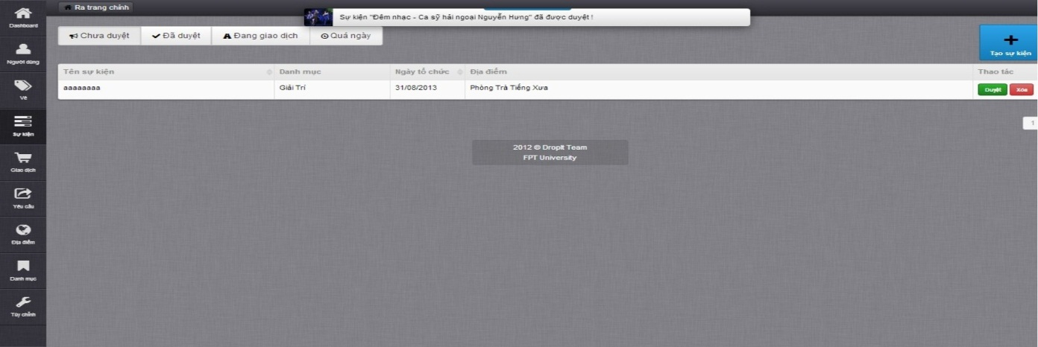

* Message approve/disapprove event success displays on top

### Create Venue

* Click “Địa điểm” tab to enter Manage Venue page

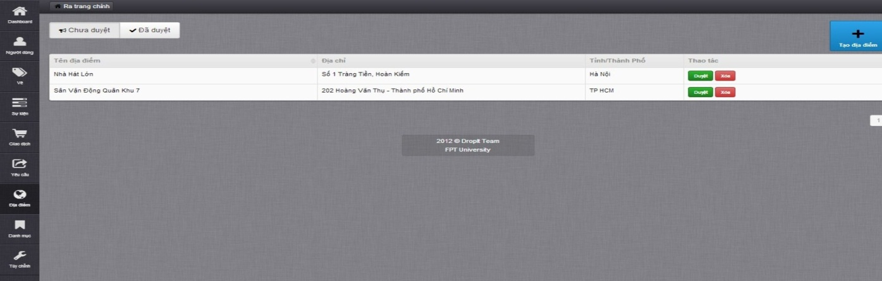

* Click on “Tạo địa điểm” button to display Create Venue page

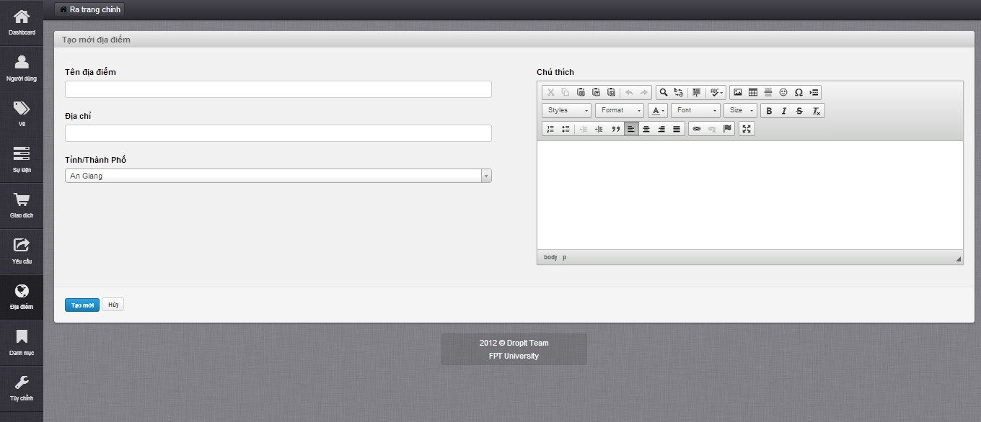

* Fill in all mandatory field
* Click on “Tạo mới” button
* After creating completed, navigate back to Manage Venue page

### Update Venue

* Click on a venue to navigate to display Update Venue page

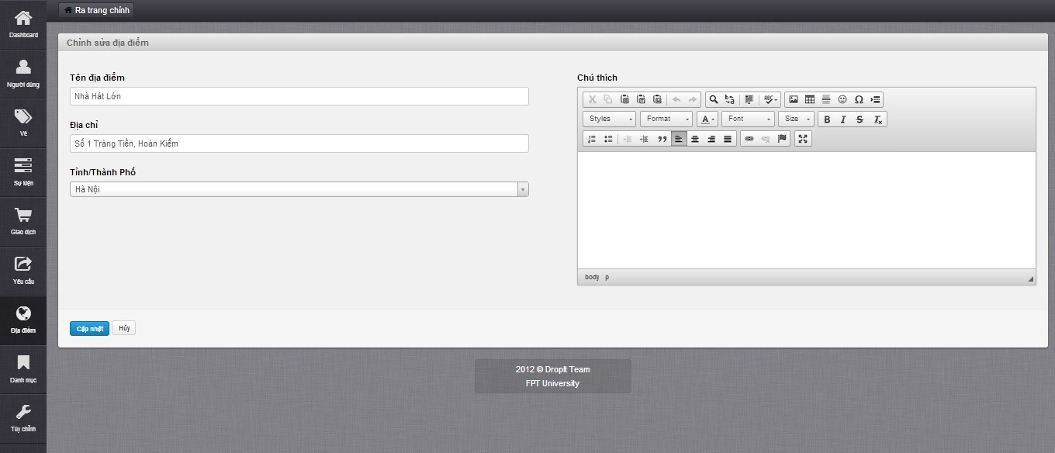

* Fill in all need-to-update mandatory field
* Click on “Cập nhật” button
* After updating completed, navigate back to Manage Venue page

### Approve/Disapprove Venue

* Click on “Duyệt” button in tab “Chưa duyệt” to approve a venue

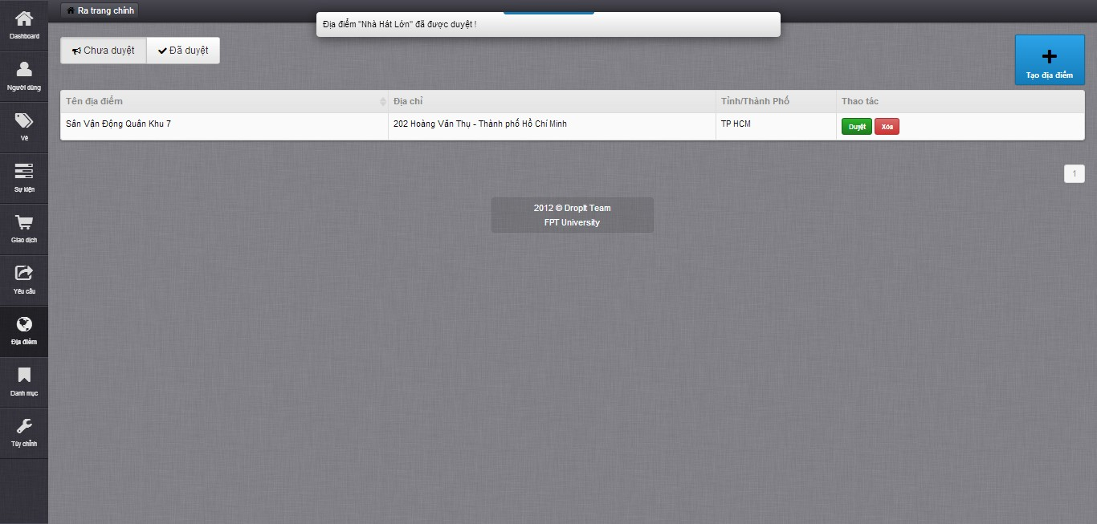

* Message approve venue successful displays on top
* Click on “Bỏ duyệt” button in tab “Đã duyệt” to disapprove a venue

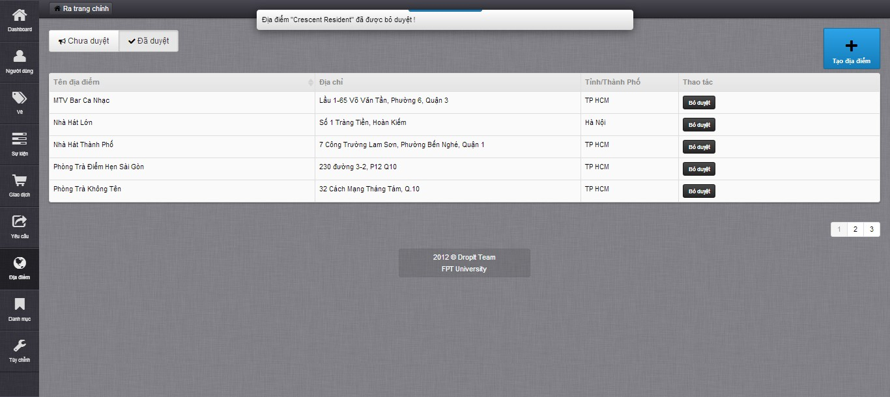

* Message disapprove venue successful displays on top

### Create Category

* Click on “Danh mục” tab to enter Manage Category page

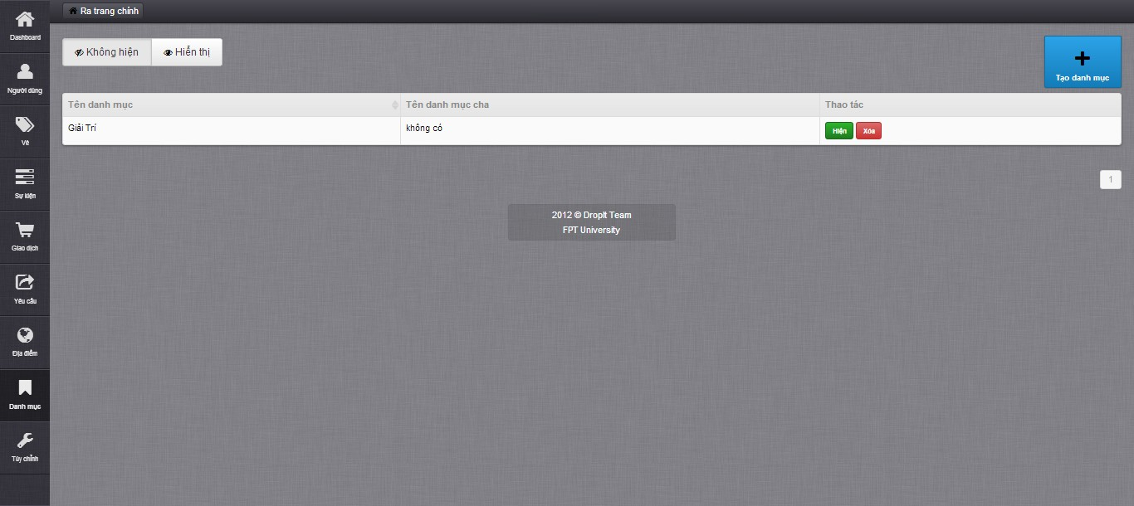

* Click on “Tạo danh mục” to display Create Category page

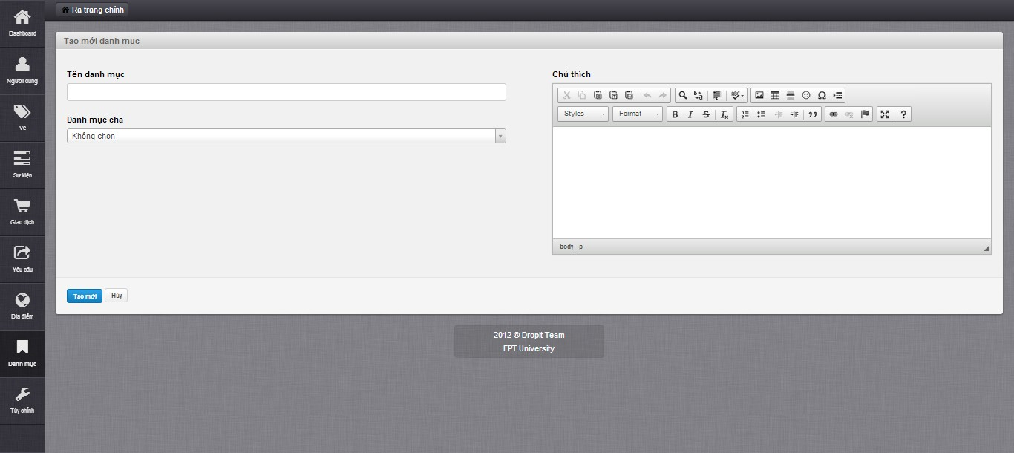

* Fill in all mandatory field
* Click on “Tạo mới” button
* After creating completed, navigate back to Manage Category page

### Update Category

* Click on a category to display Update Category page

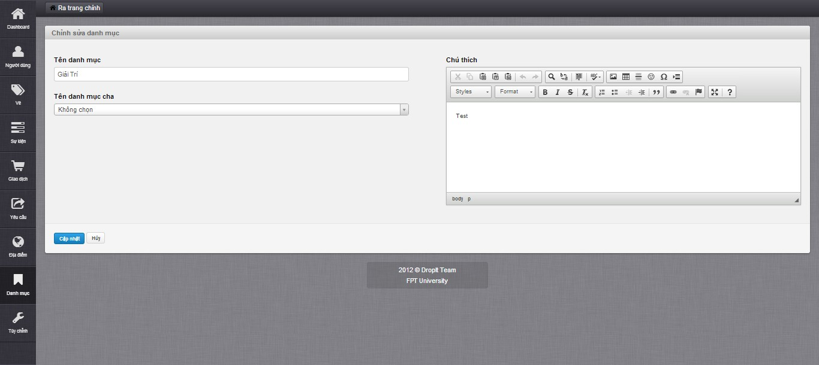

* Fill in all need-to-update mandatory field
* Click on “Cập nhật” button
* After updating completed, navigate back to Manage Category page

### Show/Hide Category

* Click on “Không hiện” tab to display list of hidden categories
* Choose a category and click “Hiện” to show hidden category

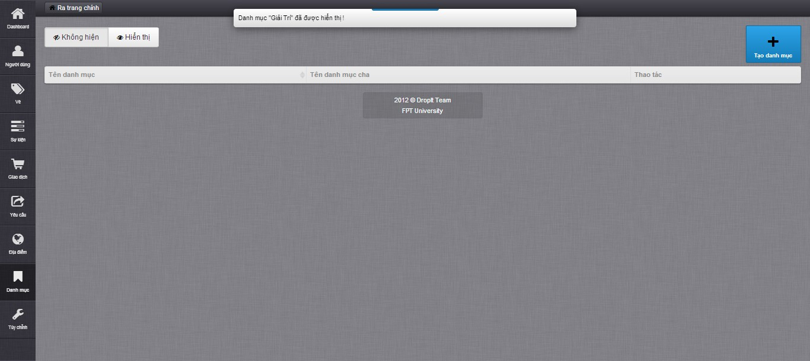

* Click on “Không hiện” tab to display list of show categories
* Choose a category and click “Ẩn” to hide category

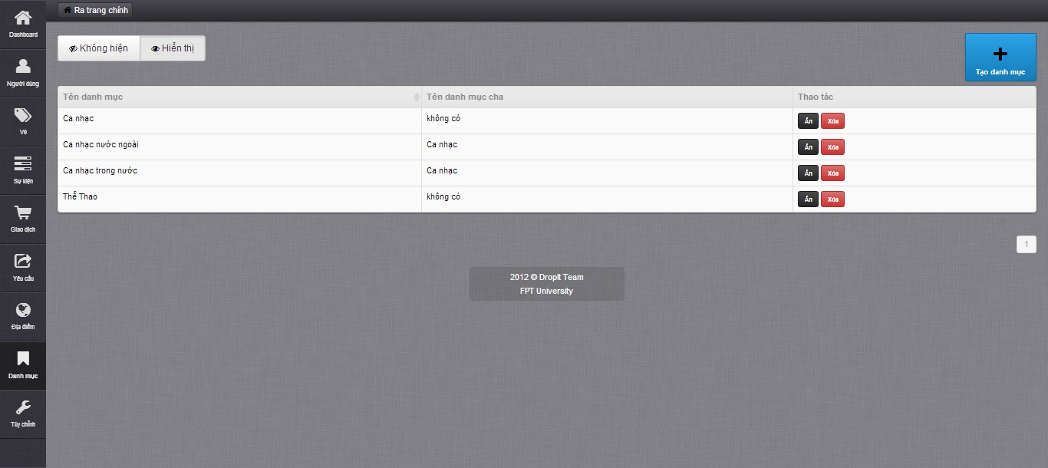

### Close Request

* Click on “ Yêu cầu” tab to enter Manage Request page
* Display list of all open requests on Manage Request page

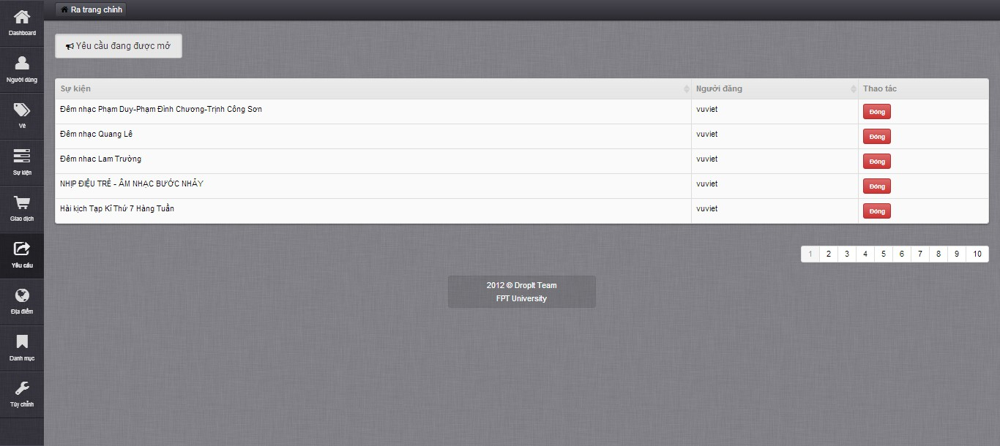

* Choose a request and click on “Đóng” button

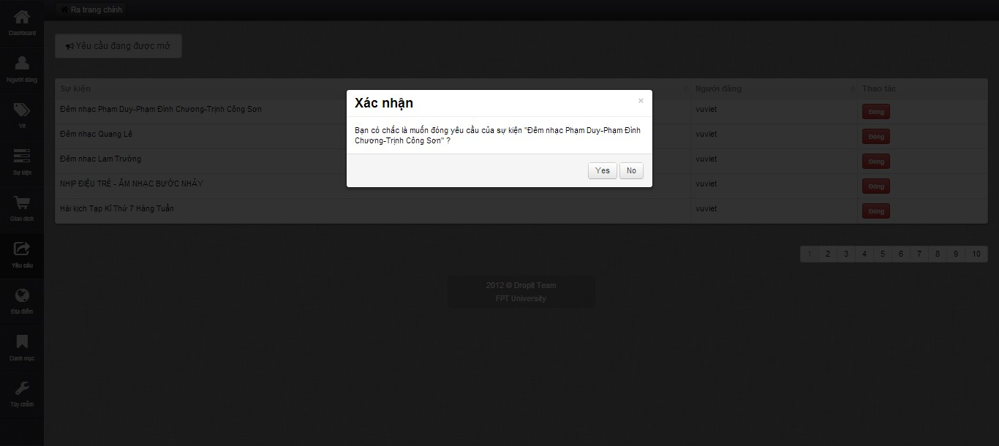

* Click on “Yes” button on confirm message to confirm close request

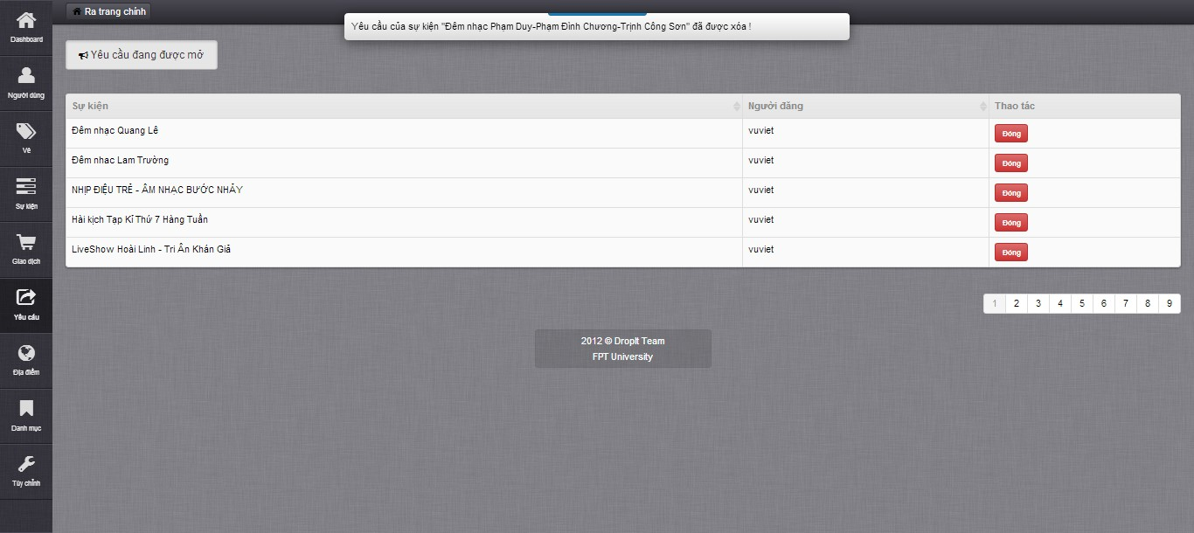

* Message close request successful displays on top

### Update Transaction

* Click on “Giao dịch” tab to enter Manage Transaction page

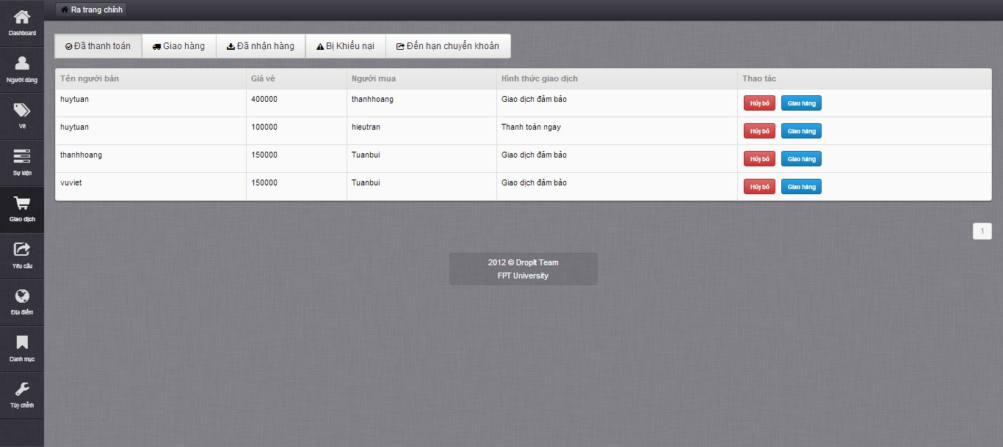

* Choose a transaction on “Đã thanh toán” tab and click “Hủy bỏ” button to cancel transaction

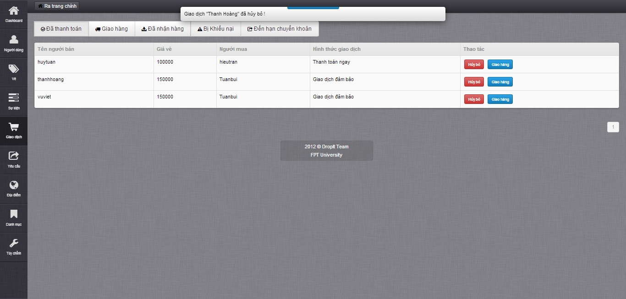

* Choose a transaction on “Đã thanh toán” tab and click “Giao hàng” button to change transaction from paid to delivered

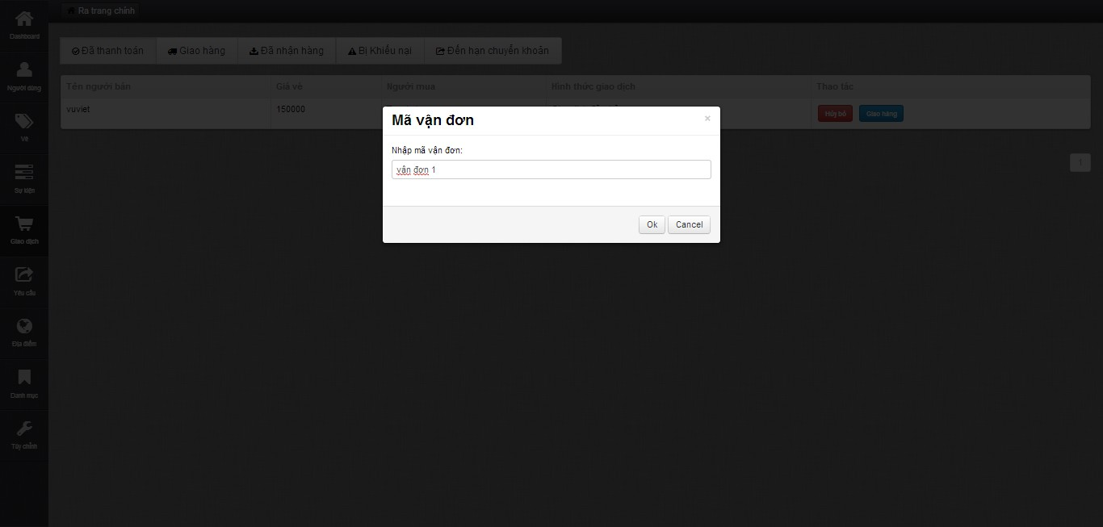

* Fill in “Mã vận đơn” and click “Ok” button to finish change transaction status

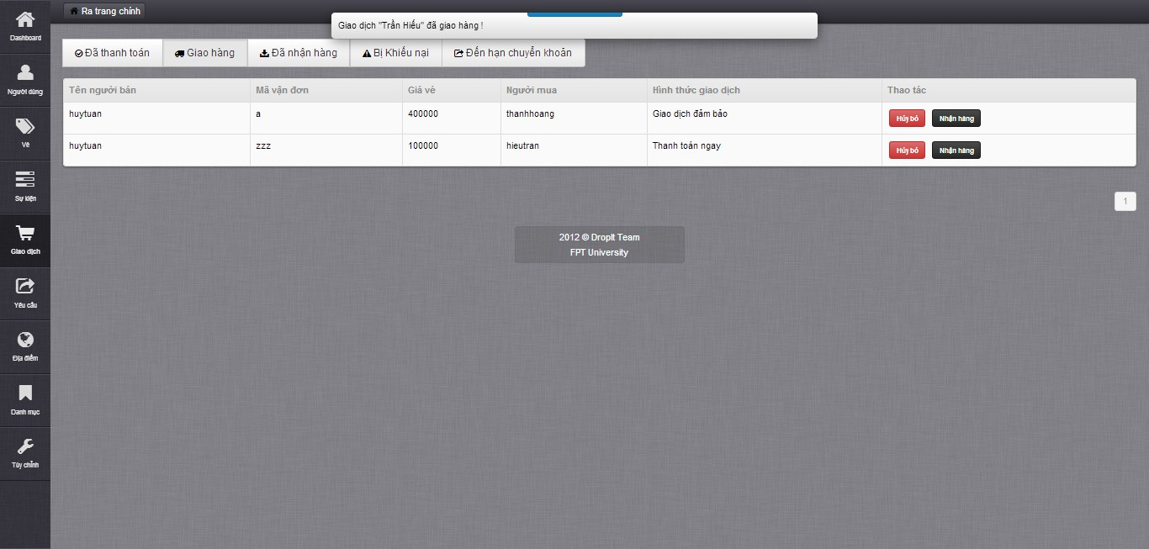

* Click “Hủy bỏ”button in “Giao hang” tab to cancel transaction if transaction got problem
* Click “Nhận hàng” in “Giao hàng” tab to change transaction status to received

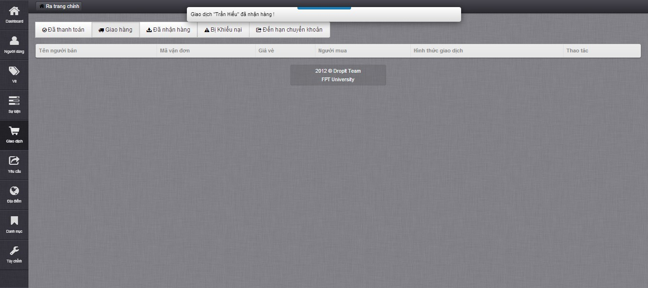

* Click on “Vé vi phạm” button in “Bị khiếu nai” to change transaction status to cancel if ticket got problem
* Click on “Vé vi phạm” button in “Bị khiếu nai” to change transaction status if ticket and transaction got no problem

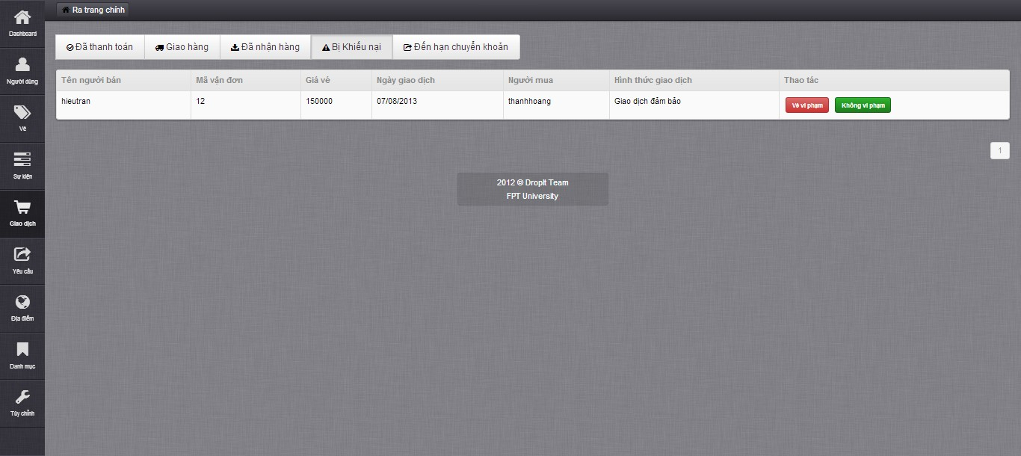

* Click on “Hoàn thành” button on “Đến hạn chuyển khoản” tab to confirm transaction done

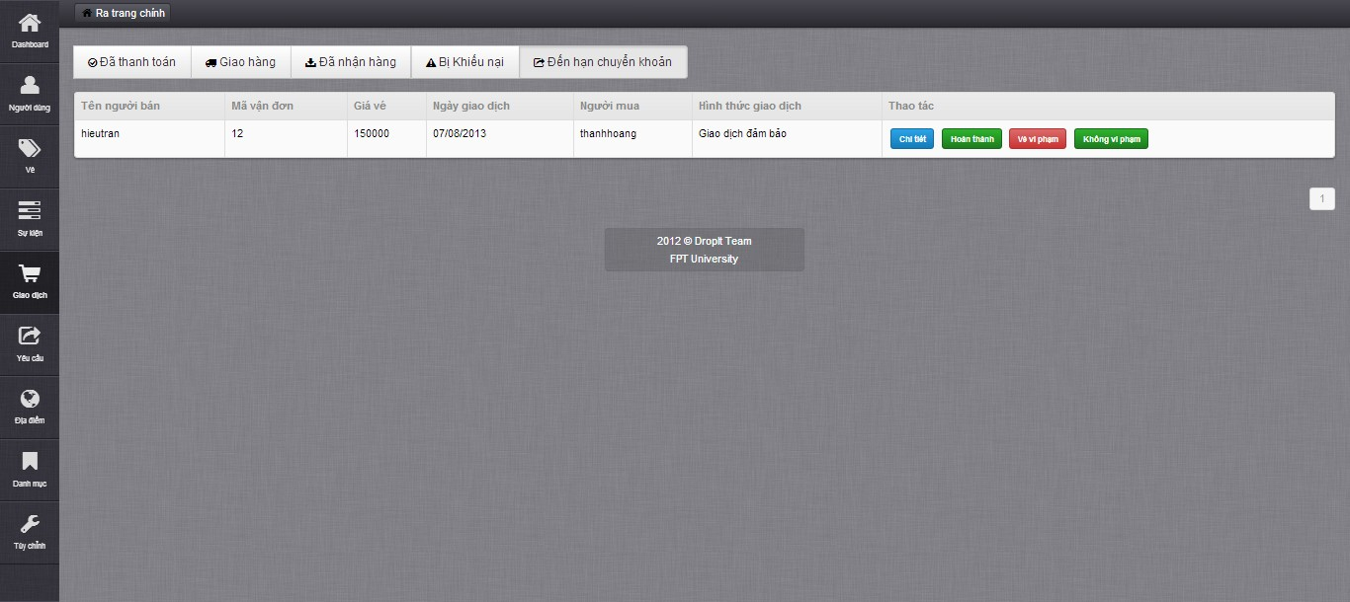

### Create Setting

* Click “Tùy chỉnh” tab to enter Manage Setting page

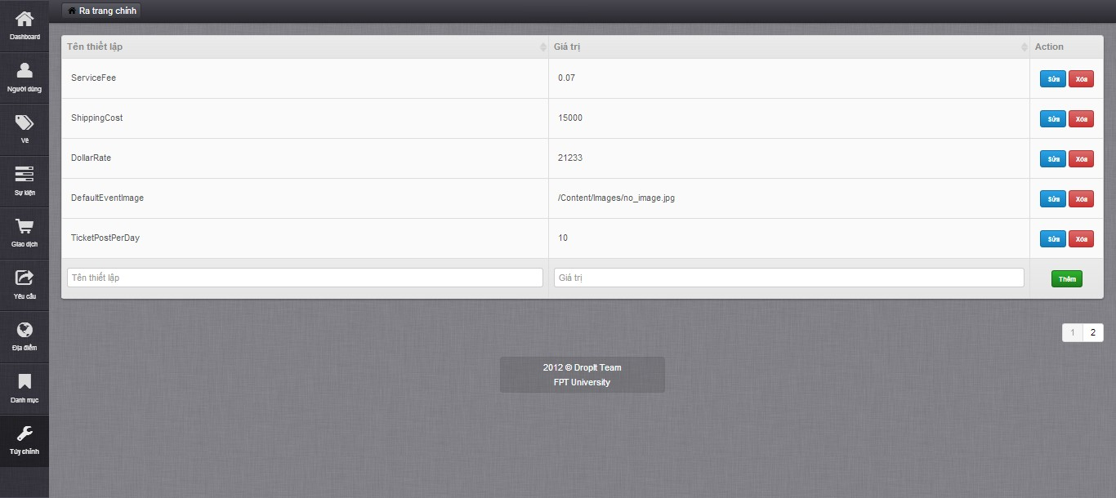

* Fill in all mandatory fields and click on “Thêm” button to create new setting

### Update Setting

* Choose a setting and click “Sửa” button to edit setting

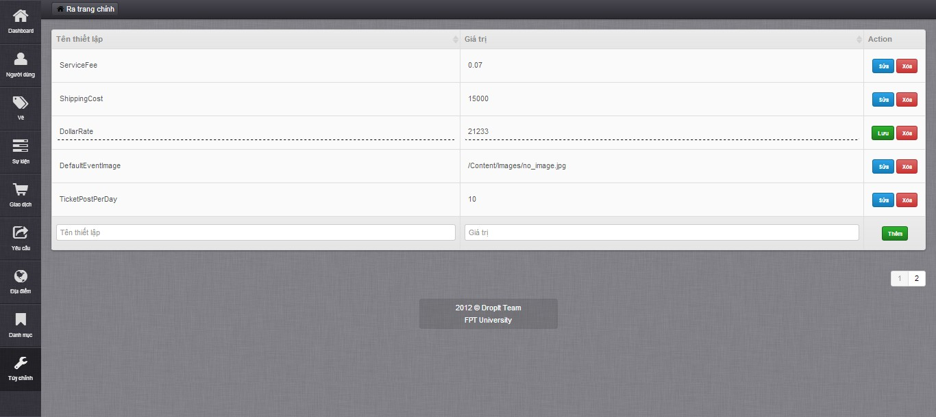

* Fill in all need-to-update mandatory field
* Click on “Lưu” button to save changes

### Delete Setting

* Choose a setting and click “Xóa” button to delete setting

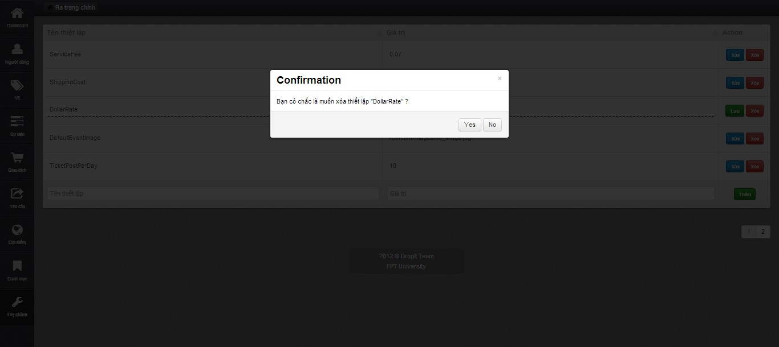

* Click “Yes” button to confirm delete setting

## **User’s Guide**

### View Website basically

* Home page interface

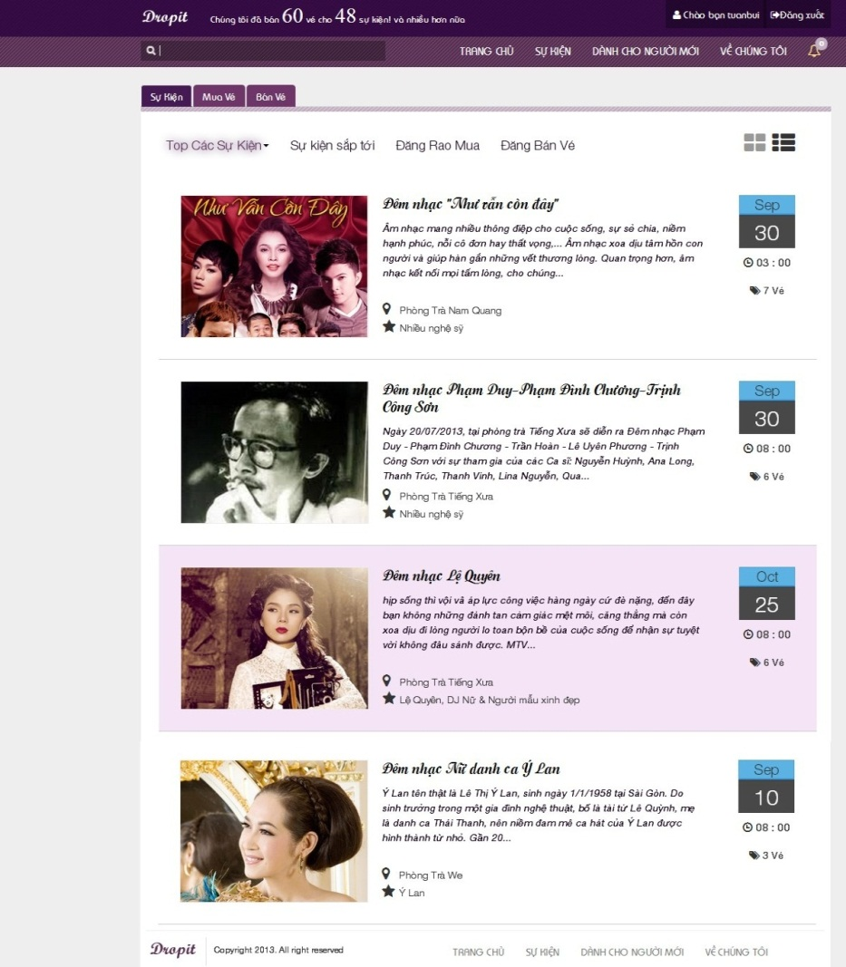

* Click on an event to view event details and information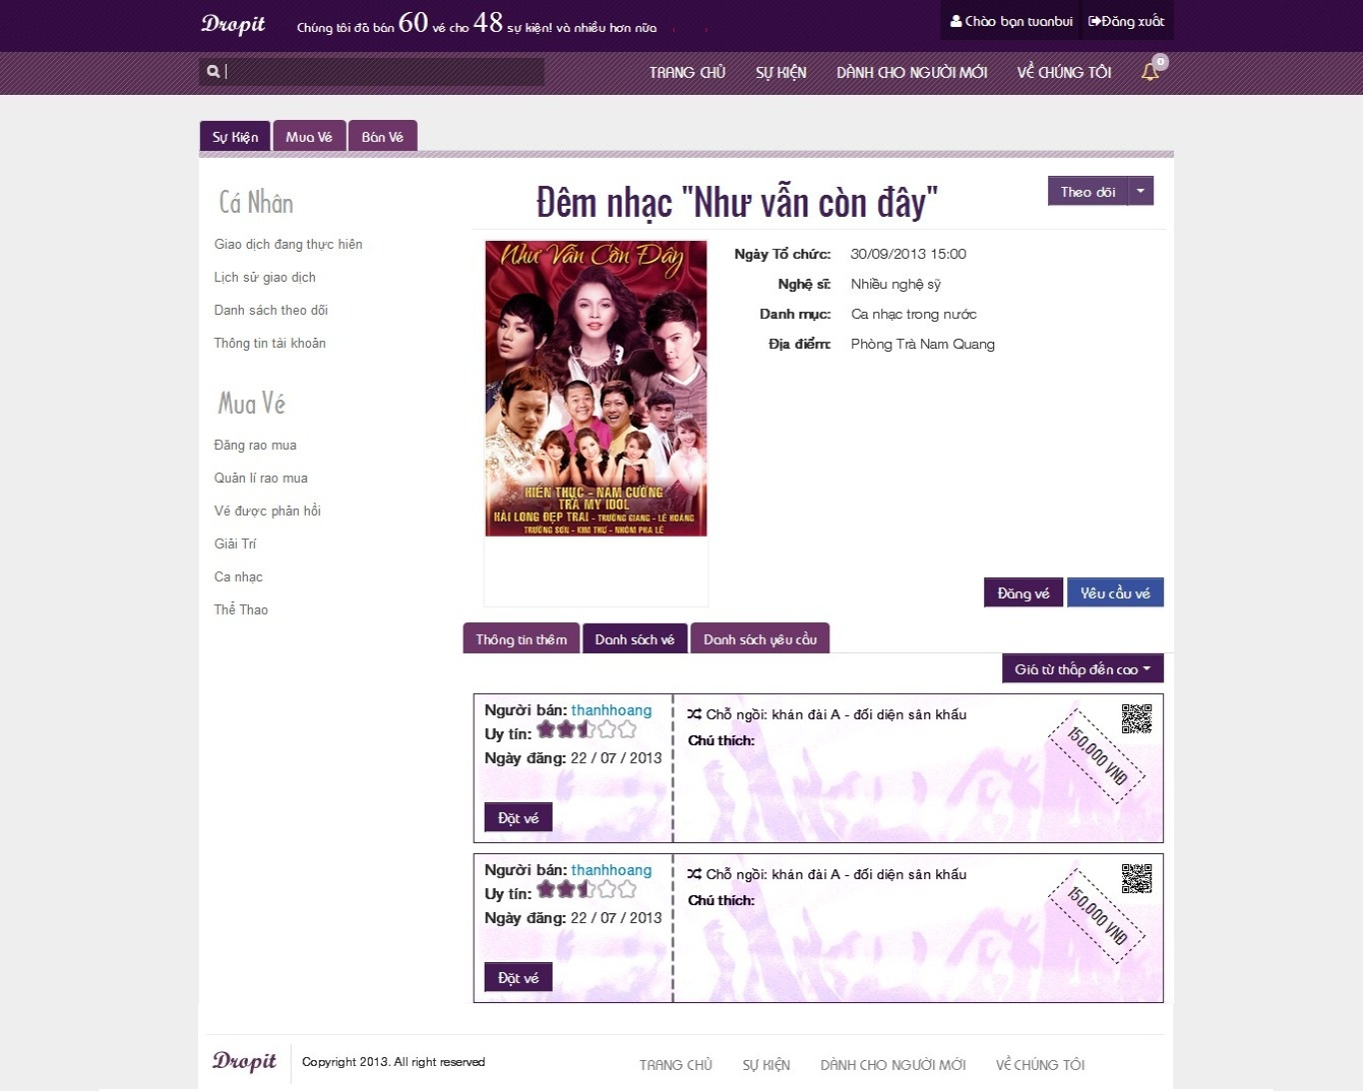

### Register

* Click on “Đăng kí” button on top right to enter Register page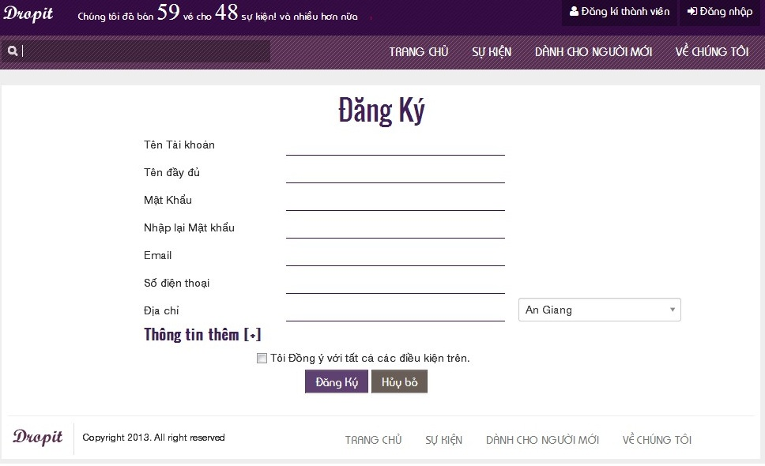
* Fill in all mandatory fields and checkbox
* Click on “Đăng ký” button to finish register

### Login

* Click on “Đăng nhập” button to login to system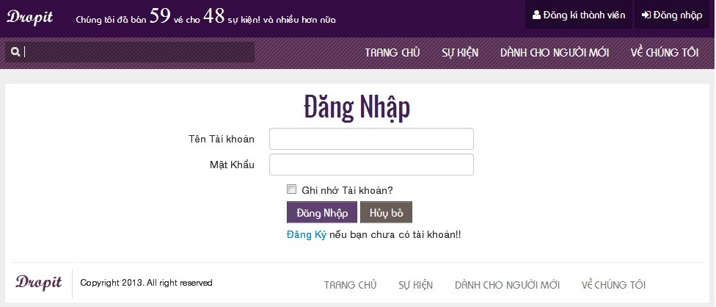
* Fill in all mandatory fields
* Click “Đăng nhập” button to login to system

### Buy Ticket

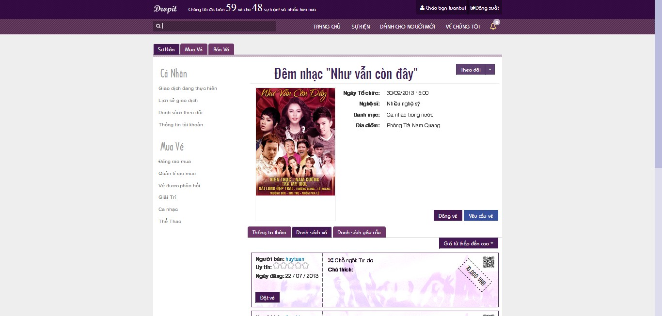

* Click on “Đặt vé” button in event page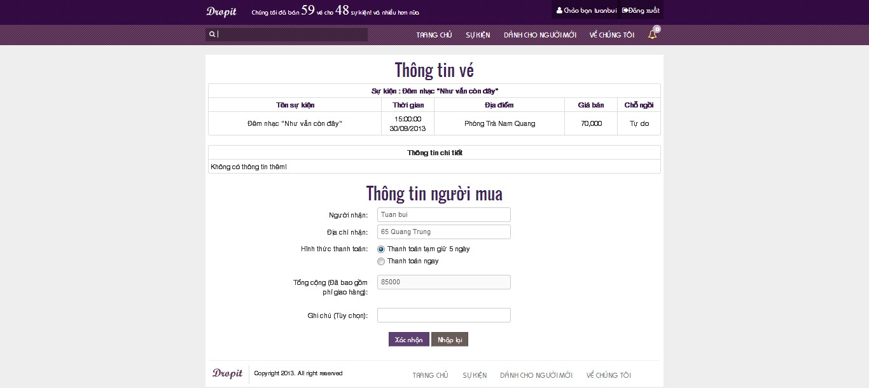
* Click on “Xác nhận” button to change to PayPal page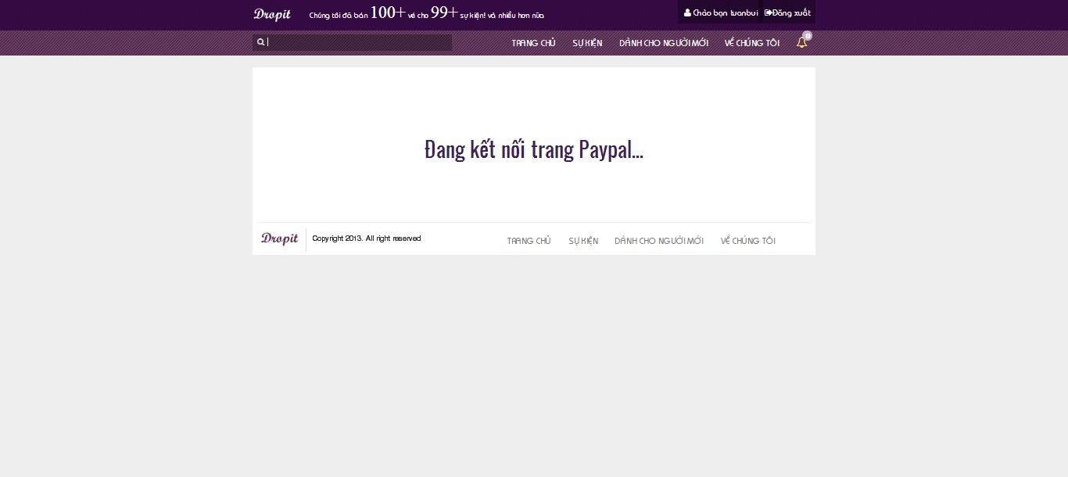
* PayPal interface
* 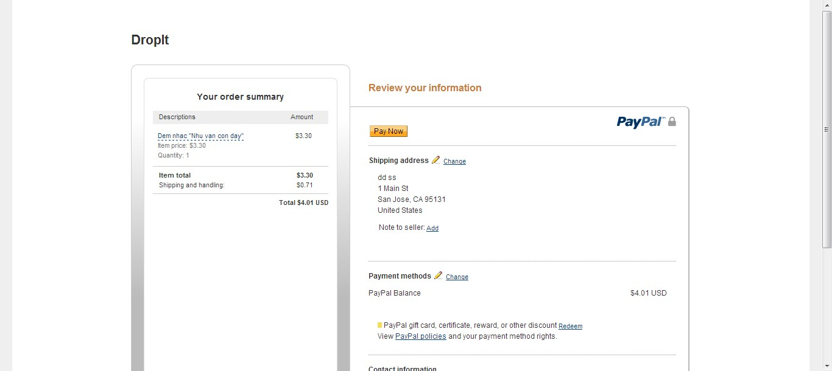
* Return Drop It system and show success page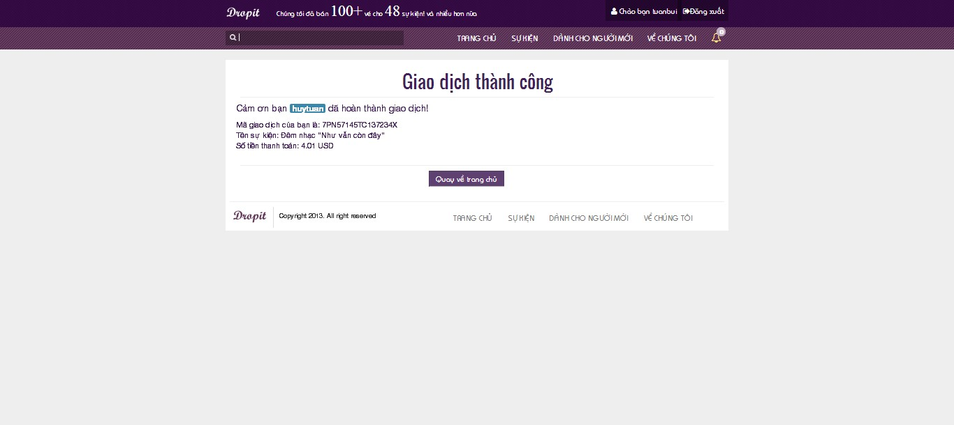

### Post Ticket

* Click on “Đăng bán vé” button in homepage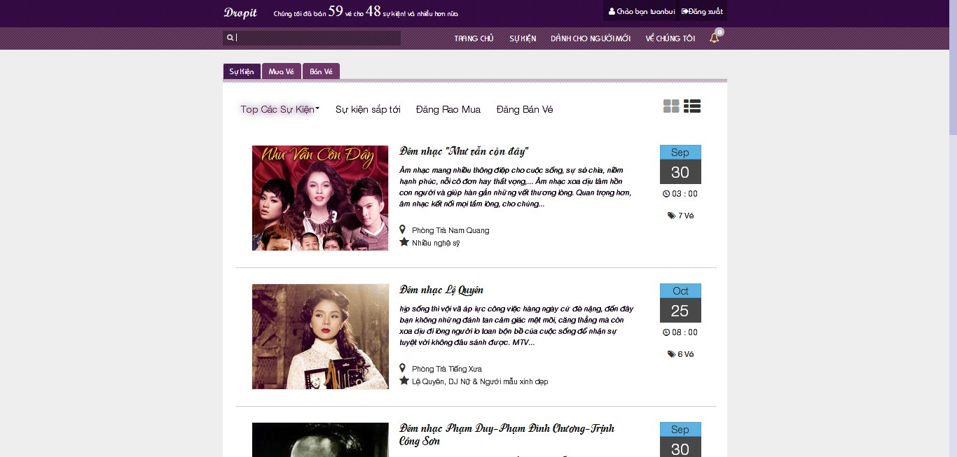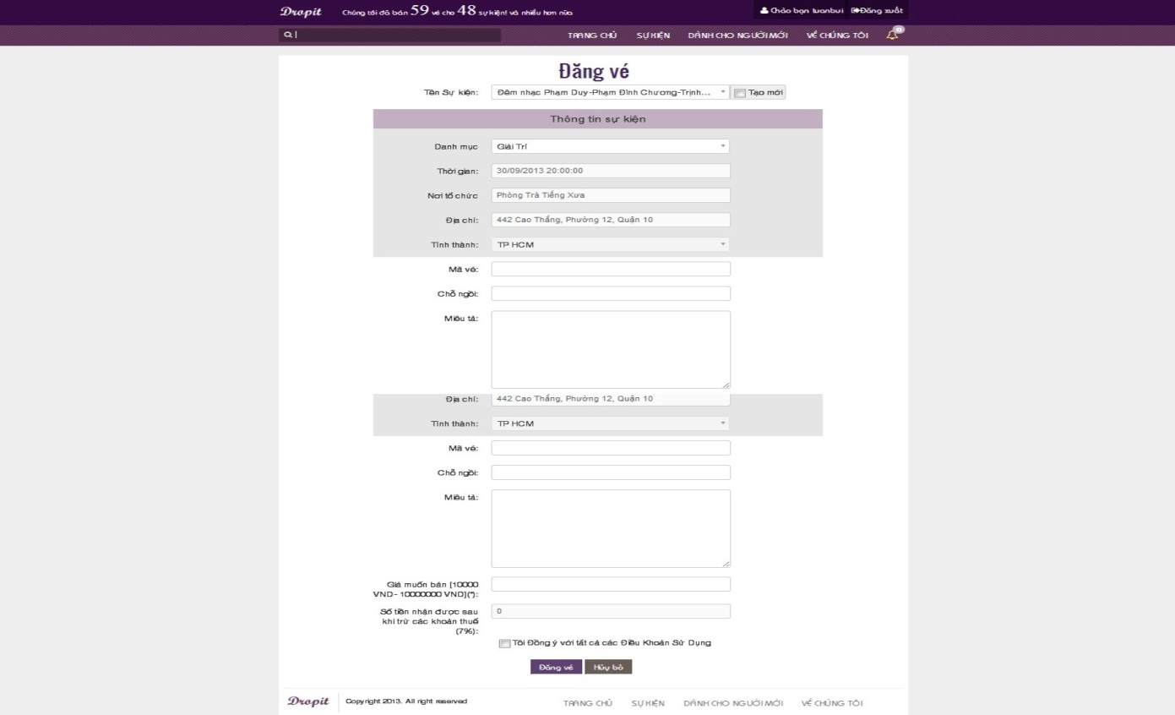
* Fill in all mandatory field
* Click “Đăng vé” button to finish post ticket

### Update Posted Ticket

* Click on “Quản lý vé” in homepage, then click on “Được phép” tab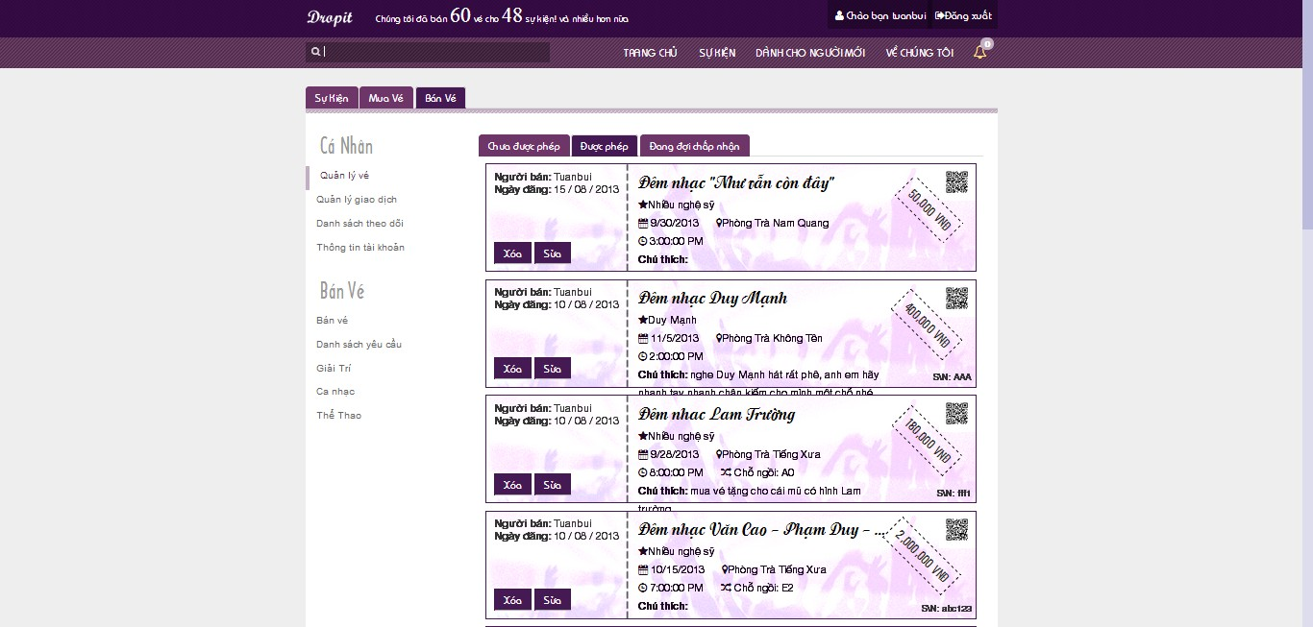
* Choose a ticket and click on “Sửa” button to display Update Ticket page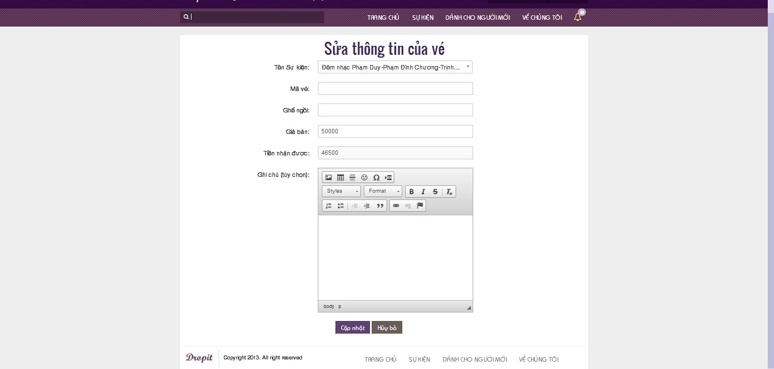
* Fill in all need-to-update mandatory fields
* Click “Cập nhật” button to finish updating
* After updating complete, navigate back to Sell Ticket page

### Delete Posted Ticket

* Choose a ticket and click on “Xóa” button to delete Ticket page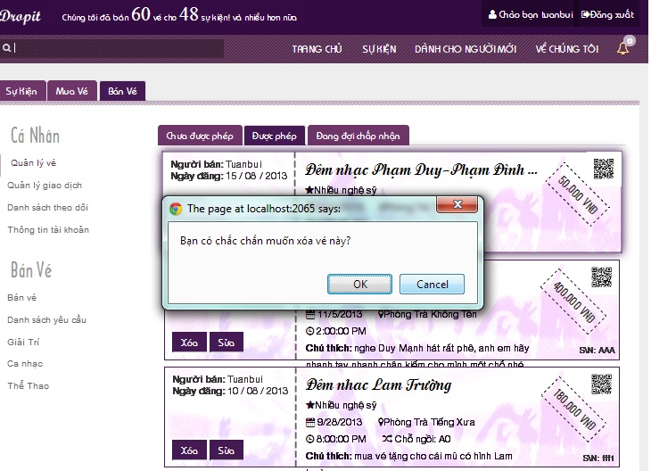
* Click “OK” button to finish delete a ticket

### Request Ticket

* Click on “Đăng rao mua” button in homepage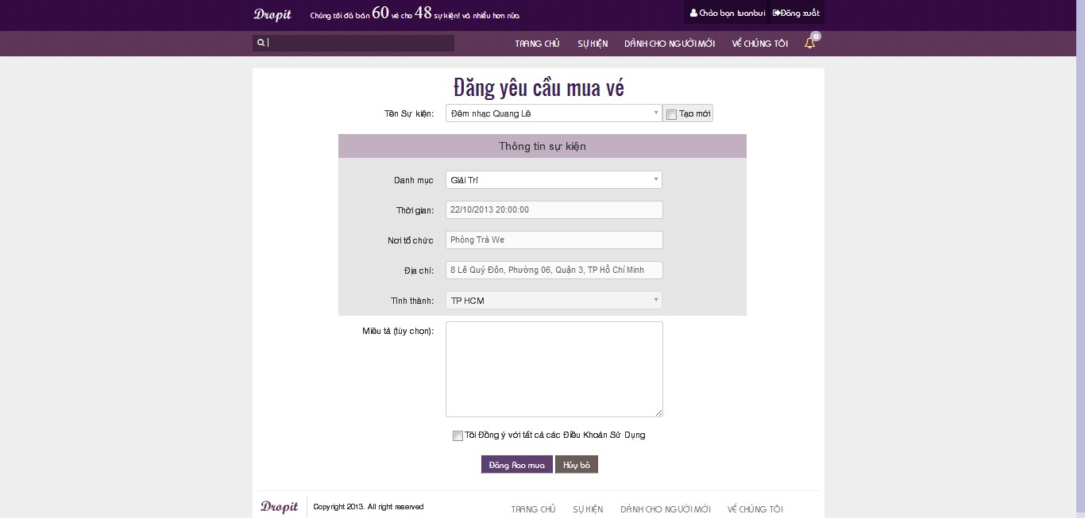
* Fill in all mandatory fields
* Click “Đăng rao mua” button to finish request ticket

### Respond Ticket

* Click on “Bán vé” tab, then click on “Danh sách yêu cầu” link on left side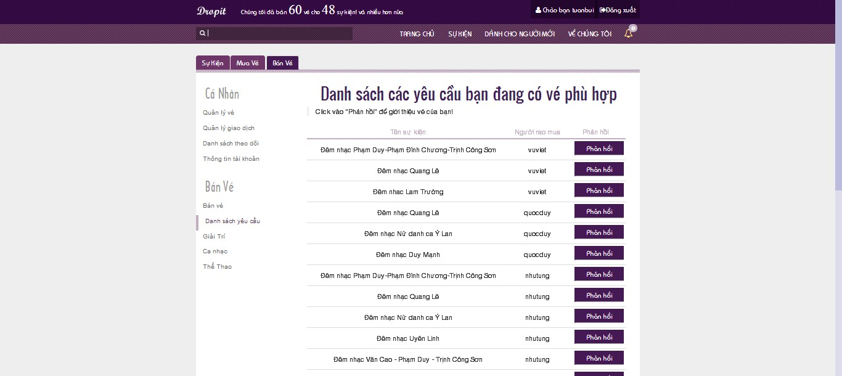
* Choose a request and click on “Phản hồi” to response ticket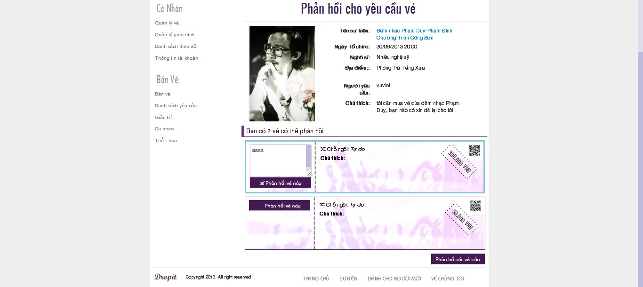
* Choose request that user has ticket for responding and click “Phản hồi các vé trên” to respond ticket

### Close Ticket Request

* Click “Mua vé” tab, then click on “Quản lí rao mua” link to view list of requests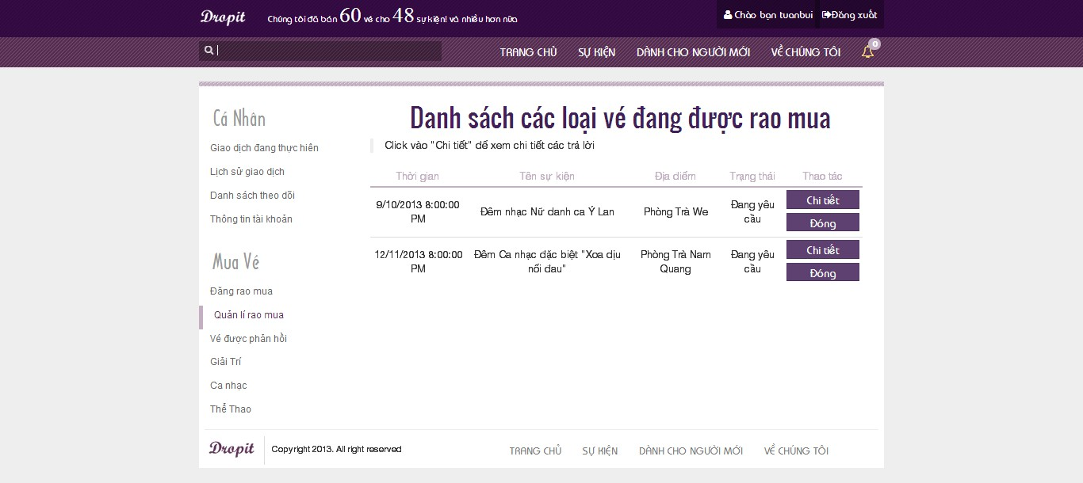
* Choose a request and click “Đóng” button to close request

### View Buy History

* Click “Mua vé” tab, then click on “Giao dịch đang thực hiện” link to view list of transactions are in progress

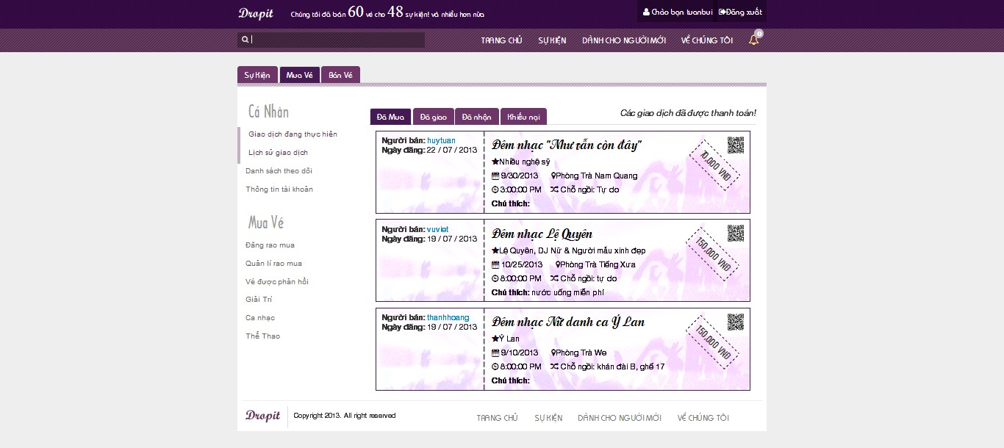

### View Sell History

* Click “Bán vé” tab, then click on “Quản lý giao dịch” link to view list of ticket transactions

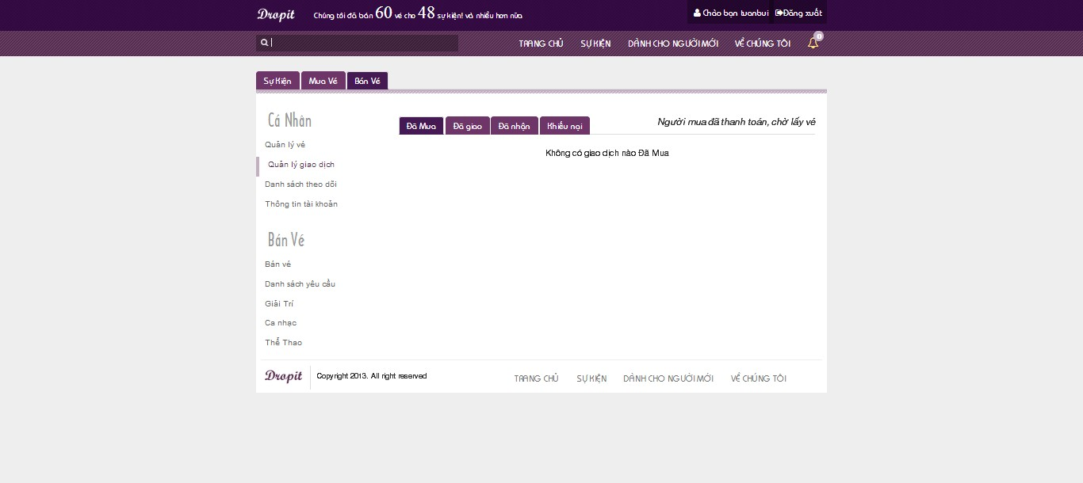

* Click “Đã mua” tab, “Đã giao” tab, “Đã nhận” tab or “khiếu nại” tab to view sell history

### Follow/Unfollow Buy Event

* Click on an event to view event details

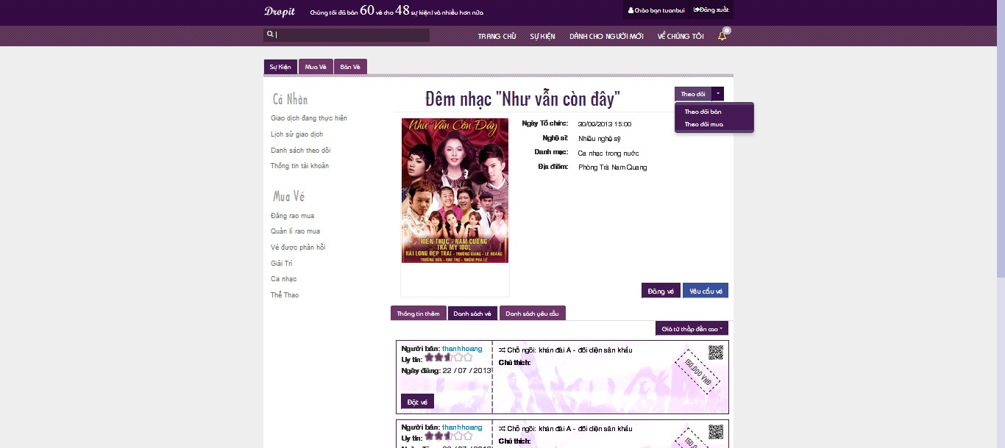

* Click on “Phản hồi” drop down list to choose “Theo dõi mua” or “Theo dõi bán” to follow buy or follow sell event
* Click on “Phản hồi” button to follow buy and sell event

### View Follow List

* Click on “Danh sách theo dõi” link in “Cá nhân” field to view list follow events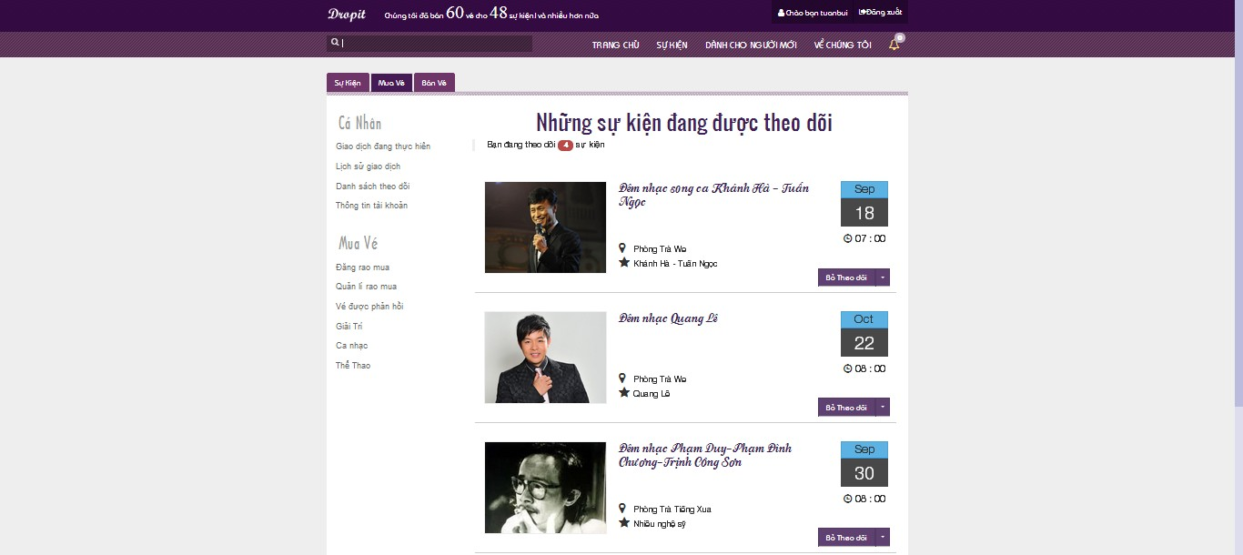

### View Notification List

* Click on alarm label on top right to view notification list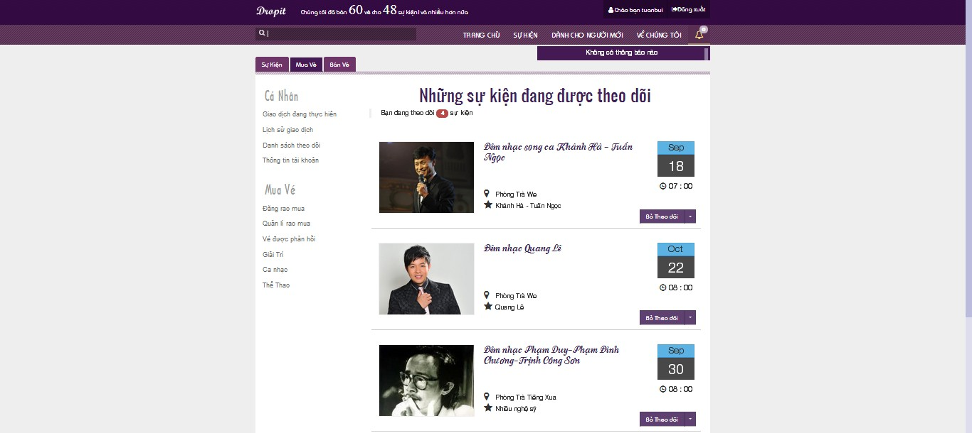

### Change Password

* Click “Bán vé” tab or “Mua vé” tab, then click on “Thông tin tài khoản” link to view personal information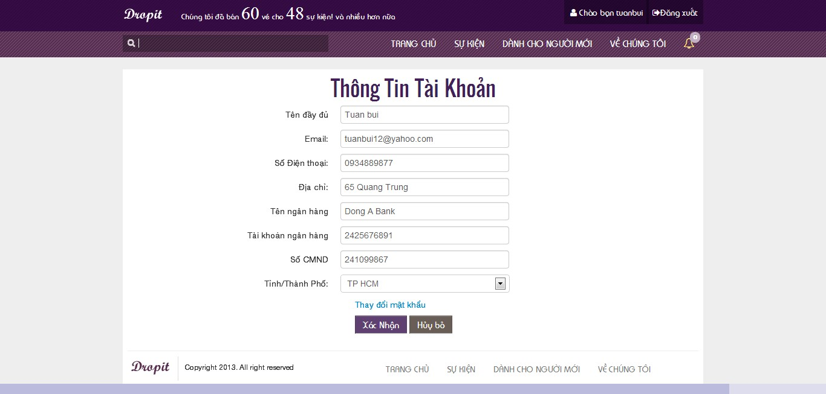
* Click “Thay đổi mật khẩu” link to display Change Password page
* Or click on username on top right to display Change Password page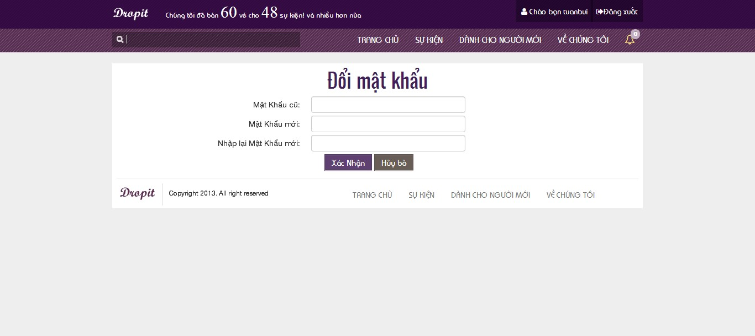
* Fill in all mandatory fields
* Click on “Xác nhận” button to finish change password

### Change Personal Information

* Click “Bán vé” tab or “Mua vé” tab, then click on “Thông tin tài khoản” link to view personal information
* Fill in all need-to-update fields
* Click on “Xác nhận” button to save changed information

### Search Event

* Input information want to search into search box, system will suggest result if there are matching results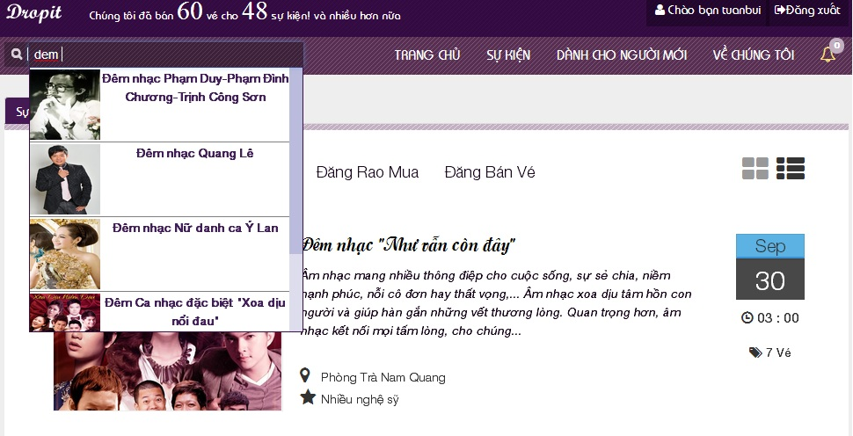
* Click on suggest result to view event
* Or continue input string want to search and click on search label or press enter key to search
* Display Search Result page

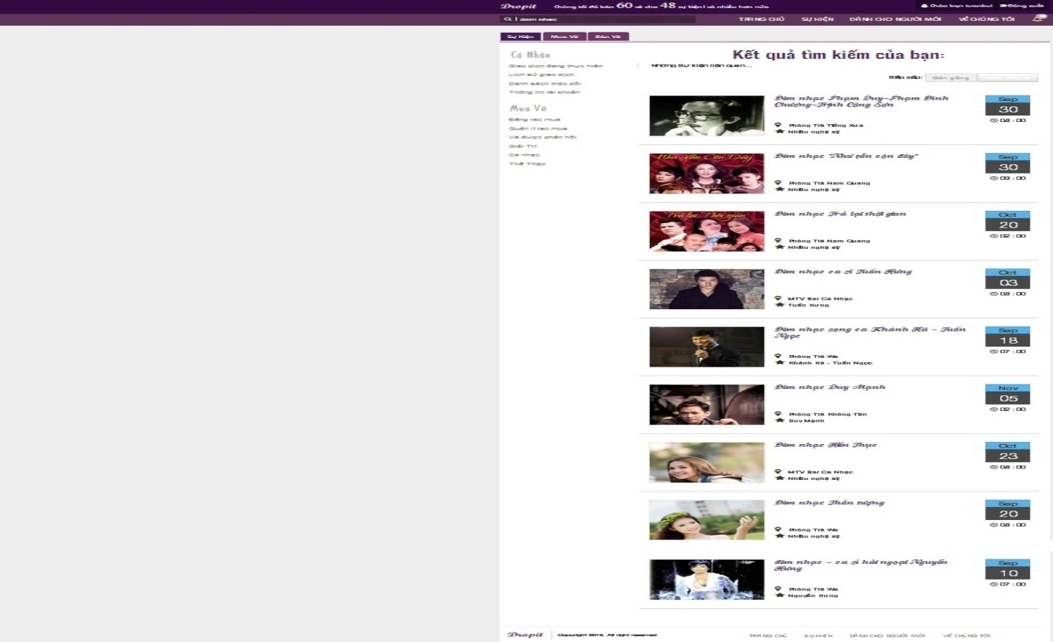

### Logout

* Click on “Đăng xuất” button at top right to logout of the system